**Train the Model on IBM**

**Cloud Deployment**

|  |  |
| --- | --- |
| Date | 18 November 2022 |
| Team ID | PNT2022TMID36535 |
| Project Name | Intelligent Vehicle Damage Assessment & Cost Estimator for Insurance Company |



LEVEL

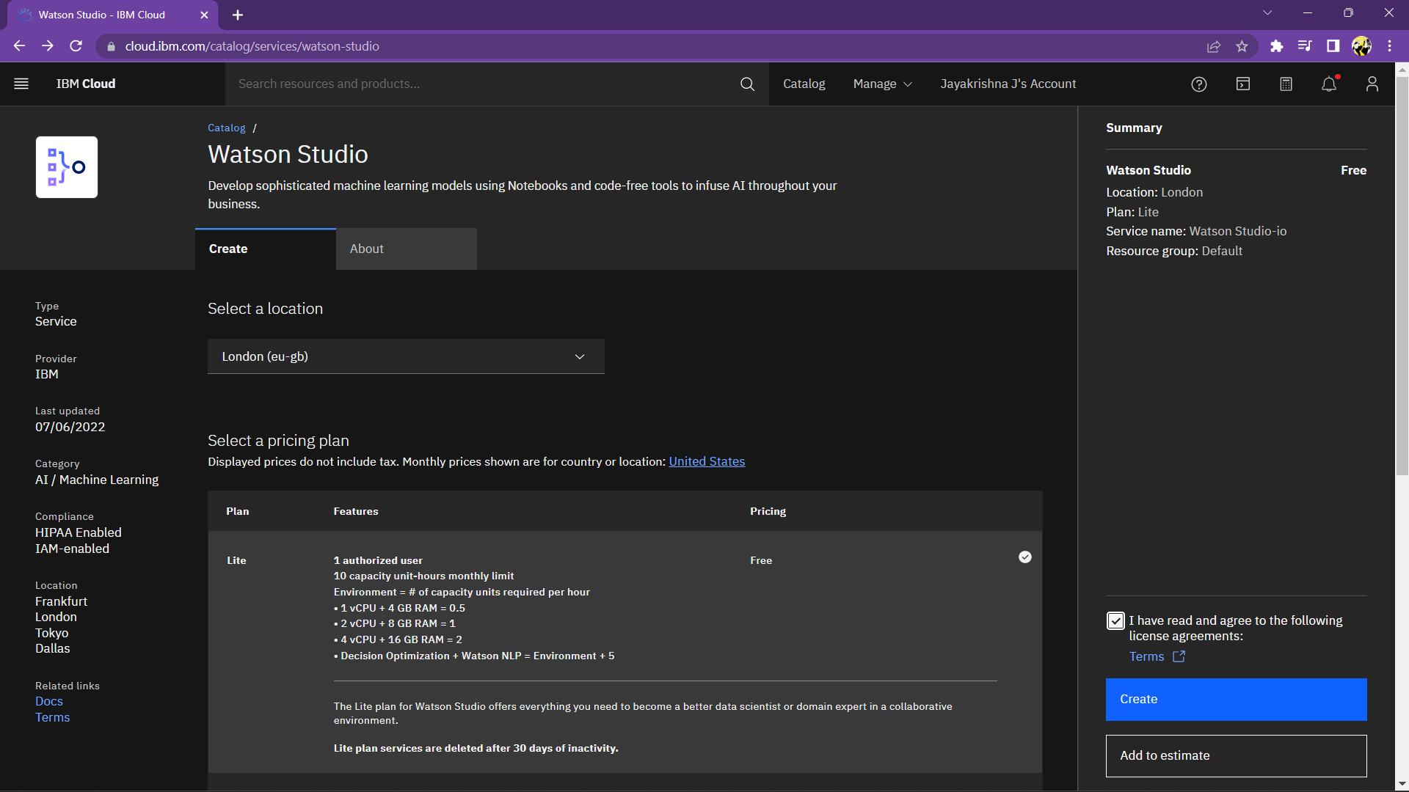Creating Watson Studio:

Creating New Deployment Space:

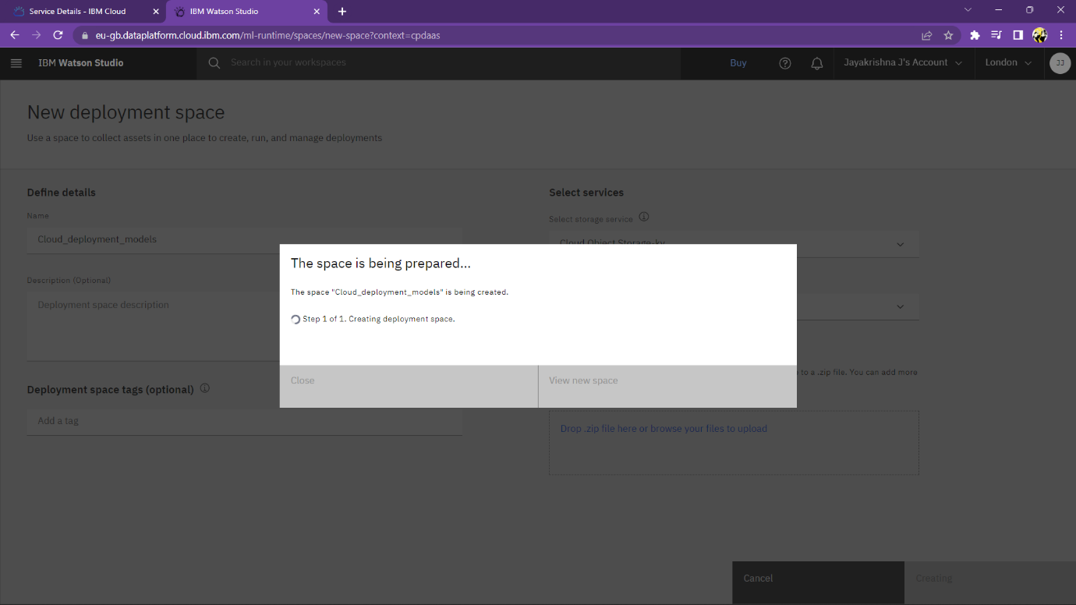

Creating Assets:

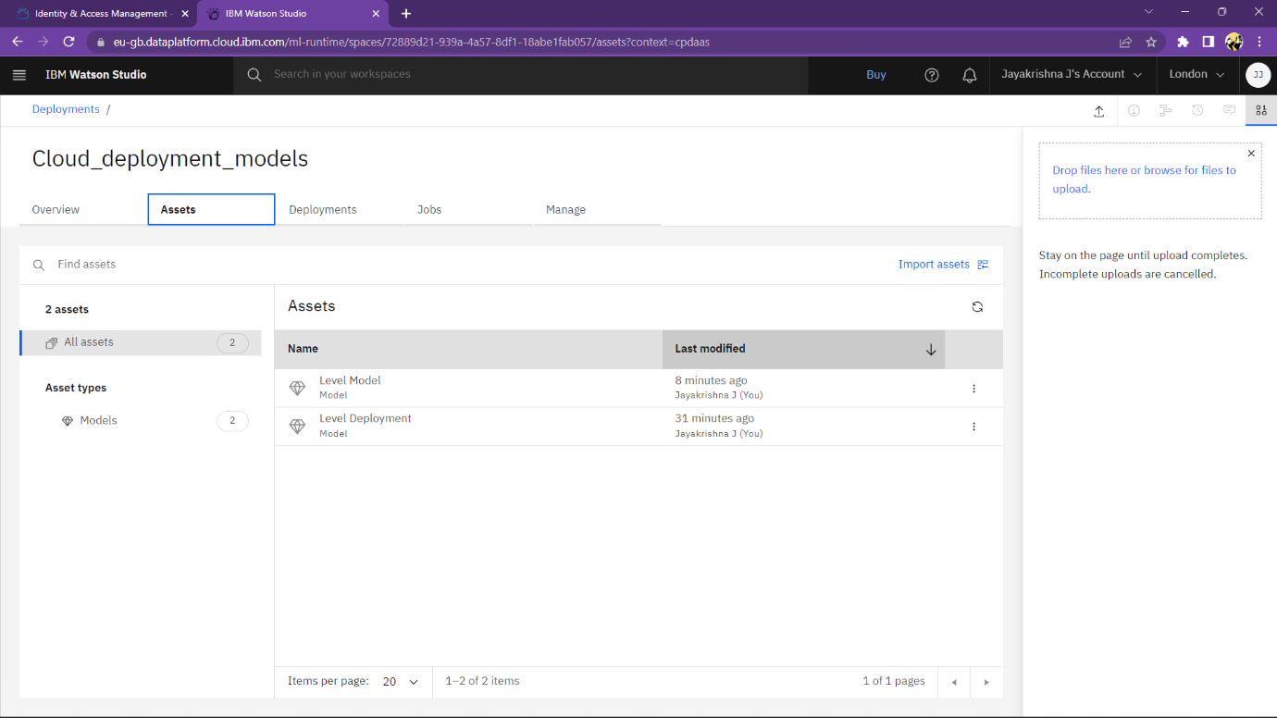

Deployment:

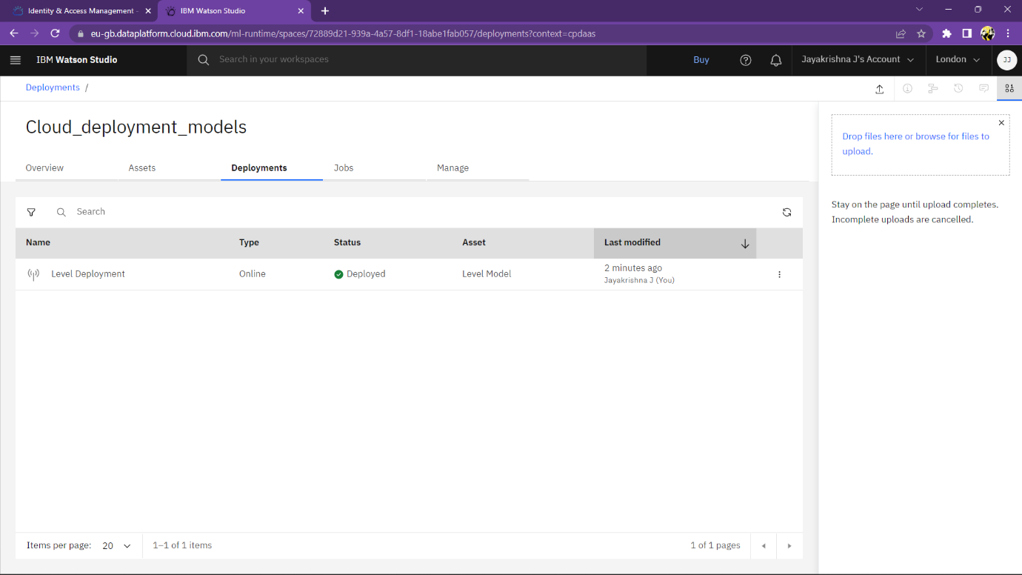

BODY

Creating New Deployment Space:

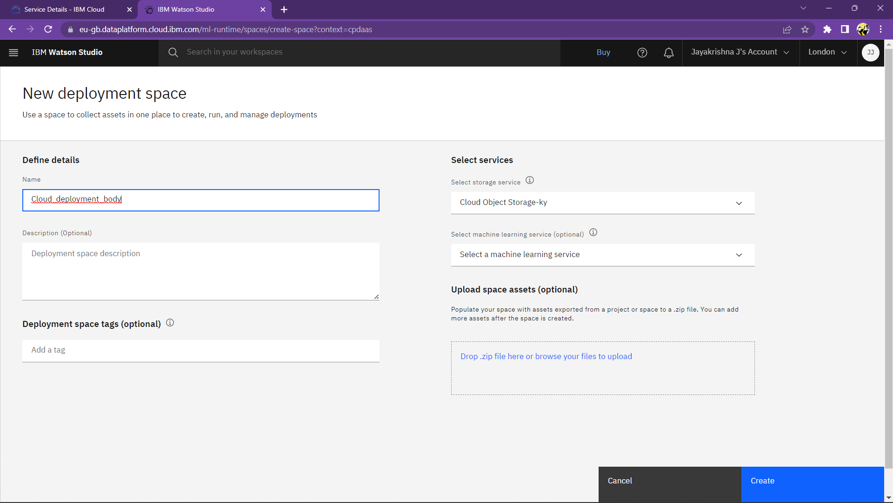

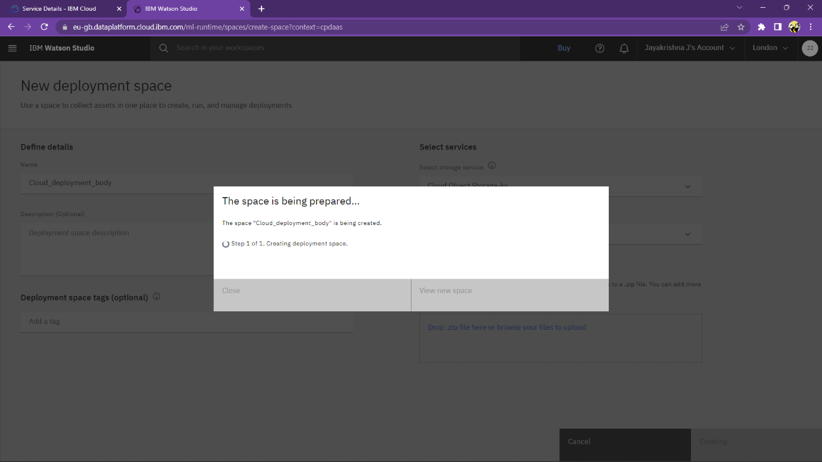

Creating Assets:

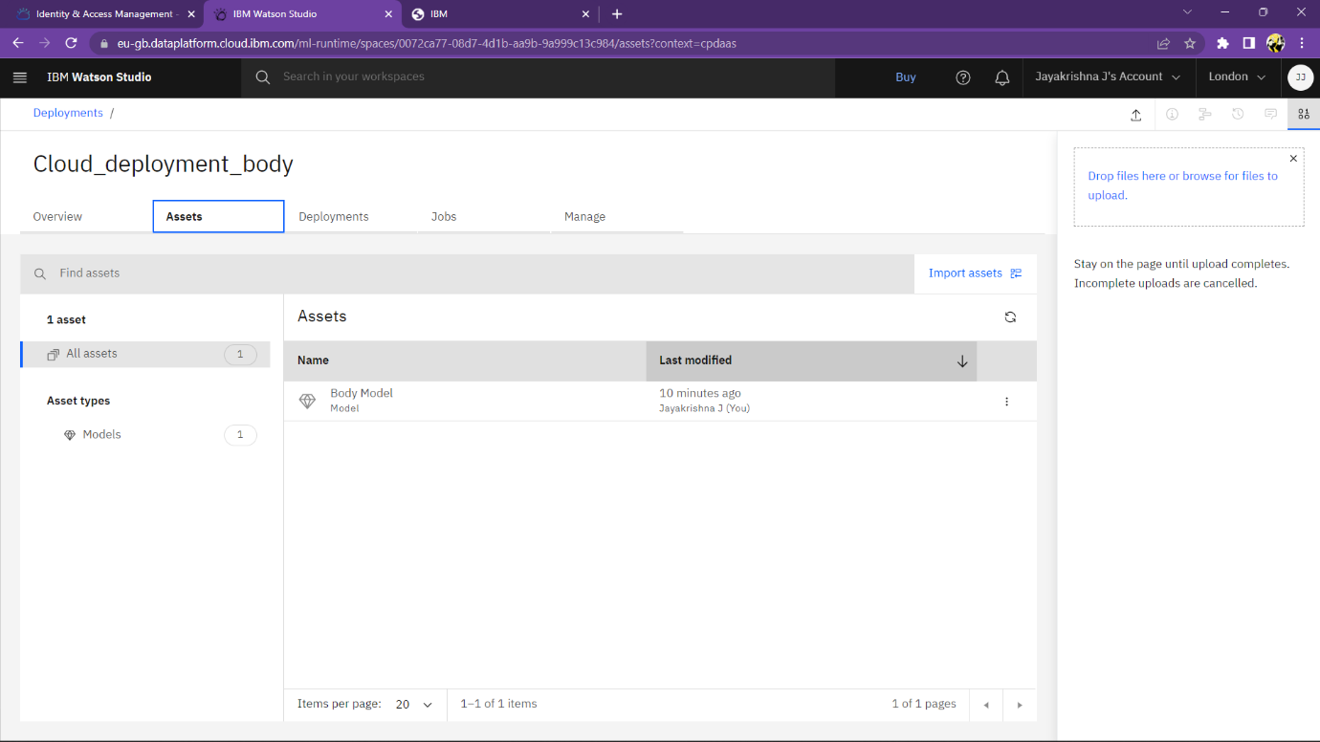

Deployment:

